
Yoga Proficiency Badge syllabus:
- Definition of Yoga
- Types of Yoga- Gyan Yoga, Karma Yoga, Ashtang Yoga, Bhakti Yoga
2. What is Ashtang (Hatha) yoga ?
What are its eight parts ? Describe briefly each of them.
3. Do’s and Don’ts during yoga practice.
4. Practice Surya Namaskara for a month.
5. Practice for a month following asanas and know their benefits on body.
- Padmasana, Vajrasana, Yogamudra, Ushtrasana, Tadasana, Ardh Kati Chakrasana, Bhujangasana, Naukasana, Vakrasana, Pawanmuktasana, Sarvangasana, Shavasana
6. Practice following Pranayama for at least one month
-Anuloma- Viloma, Kapalabhati and Bhramari
7. Be able to do Tratak for one minute

1.Definition of Yoga
Yoga is essentially a spiritual discipline based on an extremely subtle science, which focuses on bringing harmony between mind and body. It is an art and scince of healthy living.
Types of Yoga

Gyan Yoga:
Gyana means knowledge. Gyana Yoga is the path where reality is discovered through insight, practice and knowledge.

Karma Yoga:
Karma Yoga is the selfless performance of duties, where the focus is not on the fruits or outcomes but on the action itself. Continue reading to discover the true meaning of Karma Yoga, its benefits, and how you can practice it in your daily life.
Ashtang Yoga:
The word Ashtanga is comprised of two Sanskrit words, “Ashta” and “Anga.” “Ashta” refers to the number eight, while “Anga” means limb or body part. Therefore, Ashtanga is the union of the eight limbs of yoga, into one complete, holistic system.
Bhakti Yoga:
Bhakti yoga is one of the four classical schools of yoga alongside Jnana (knowledge or self-study), Karma (action) and Raja (meditation), each offering a path to moksha (spiritual liberation) and self-realization.
2. What is Ashtang (Hatha) yoga ?
The word Ashtanga is comprised of two Sanskrit words, “Ashta” and “Anga.” “Ashta” refers to the number eight, while “Anga” means limb or body part. Therefore, Ashtanga is the union of the eight limbs of yoga, into one complete, holistic system.
The Ashtanga philosophy is to integrate all of the eight limbs of yoga, which include: Yama (moral codes), Niyama (self-discipline), Asana (posture), Pranayama (breath control), Pratyahara (sense withdrawal), Dharana (concentration), Dhyana (meditation), and Samadhi (oneness with the self).
3.Do’s and Don’ts during yoga practice
DO'S:
- Śauca means cleanliness - an important prerequisite for Yoga practice. It includes cleanliness of surroundings, body and mind.
- Asanas should be practiced on an empty stomach. Consume small amount of honey in lukewarm water if you feel weak.
- Yogic practices shall be performed slowly, in a relaxed manner, with awareness of the body and breath.
- A Warm up or loosening exercise and stretches before asanas is mandatory to avoid injuries.
- Try to eat Satvik food (Avoid meat, eggs, onion, garlic and mushrooms from diet).
- Stay hydrated before going into yoga practice
- Use a mat with a good grip to do Yogasanas
- Be aware of breathing while doing Yogasanas.
- Complete the yoga session with relaxation techniques to cool down
- Do not hold the body tight or give undue jerks to the body.
DON'TS:
- Yoga should not be performed in a state of exhaustion, illness, in a hurry or in an acute stress conditions.
- Women should refrain from regular yoga practice especially asanas during their menses. Relaxation techniques and pranayama can be done instead.
- Don’t perform yoga immediately after meals. Wait until 2 to 3 hours after a large meal.
- Don’t shower or drink water or eat food for 30 minutes after doing yoga.
- During illness, surgeries, or any sprains or fractures, one should refrain from Yoga Practice. They can resume yoga after consulting experts
- Don’t do strenuous exercises after yoga.
- Don’t practice yoga in adverse and extreme weather conditions (too hot, too cold or humid)
4. Practice Surya Namaskara for a month.
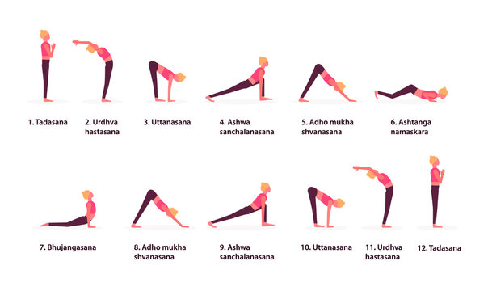
5. Practice for a month following asanas and know their benefits on body.
- Padmasana, Vajrasana, Yogamudra, Ushtrasana, Tadasana, Ardh Kati Chakrasana, Bhujangasana, Naukasana, Vakrasana, Pawanmuktasana, Sarvangasana, Shavasana

Padmasana
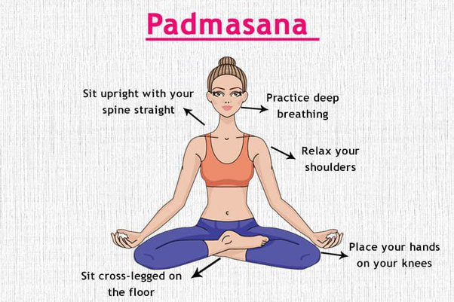

Vajrasana
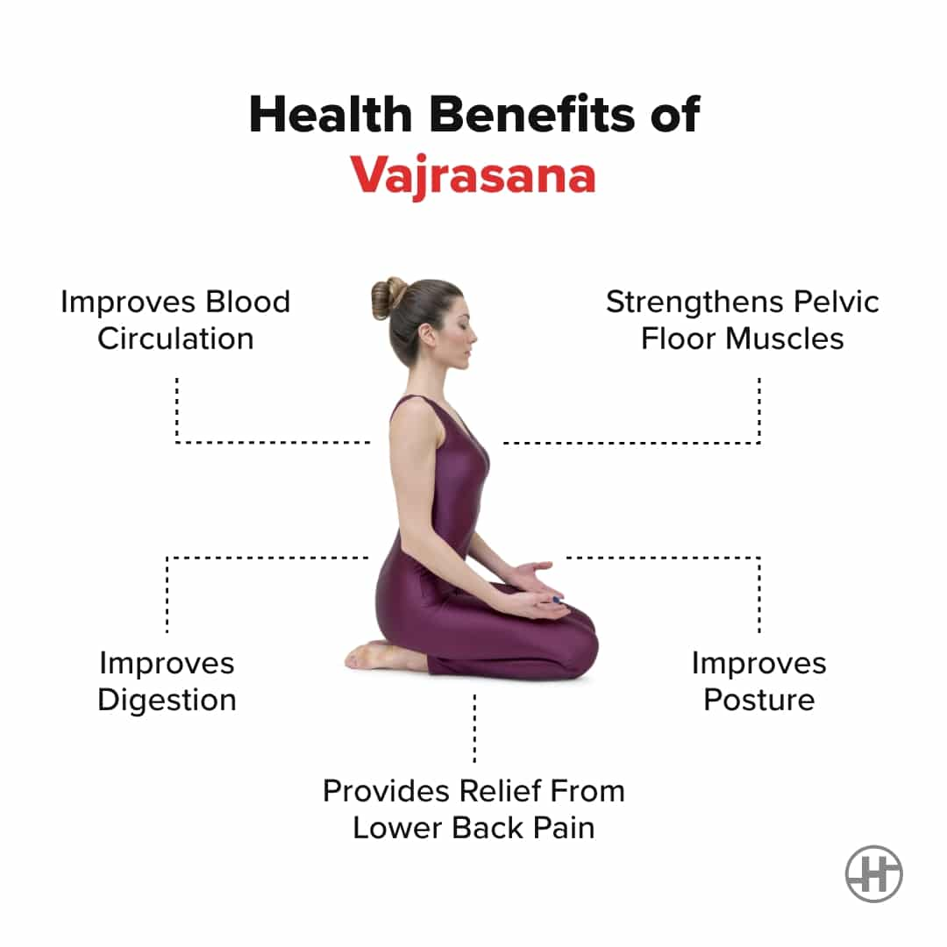

Yogamudra
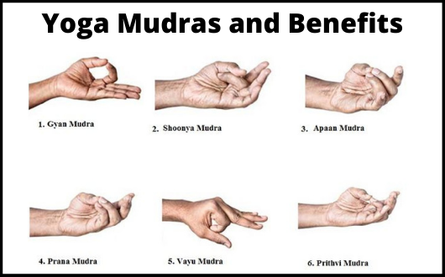

Ushtrasana
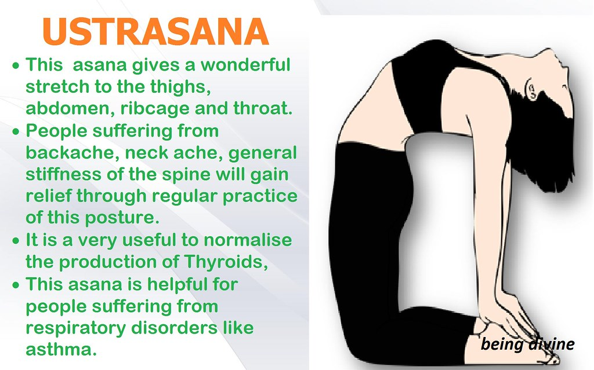

Tadasana
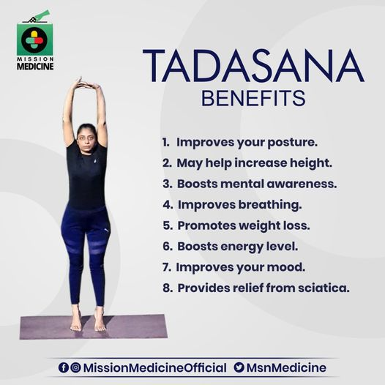

Ardh Kati Chakrasana
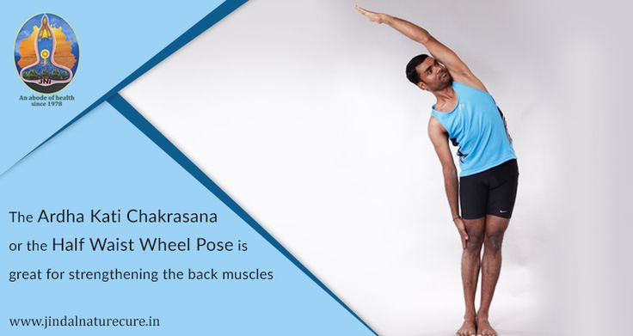

Bhujangasana
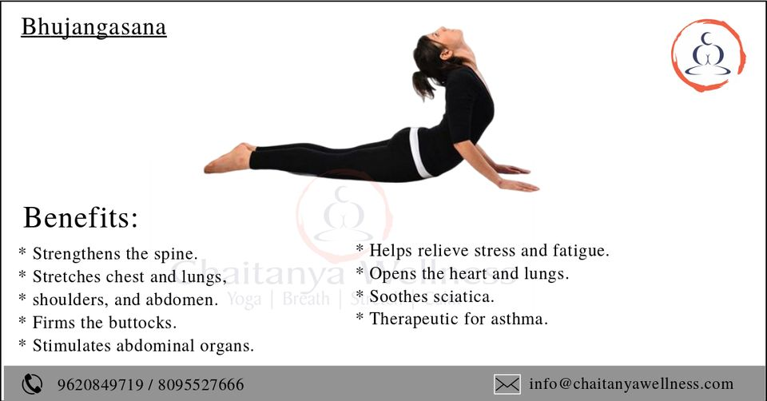

Naukasana
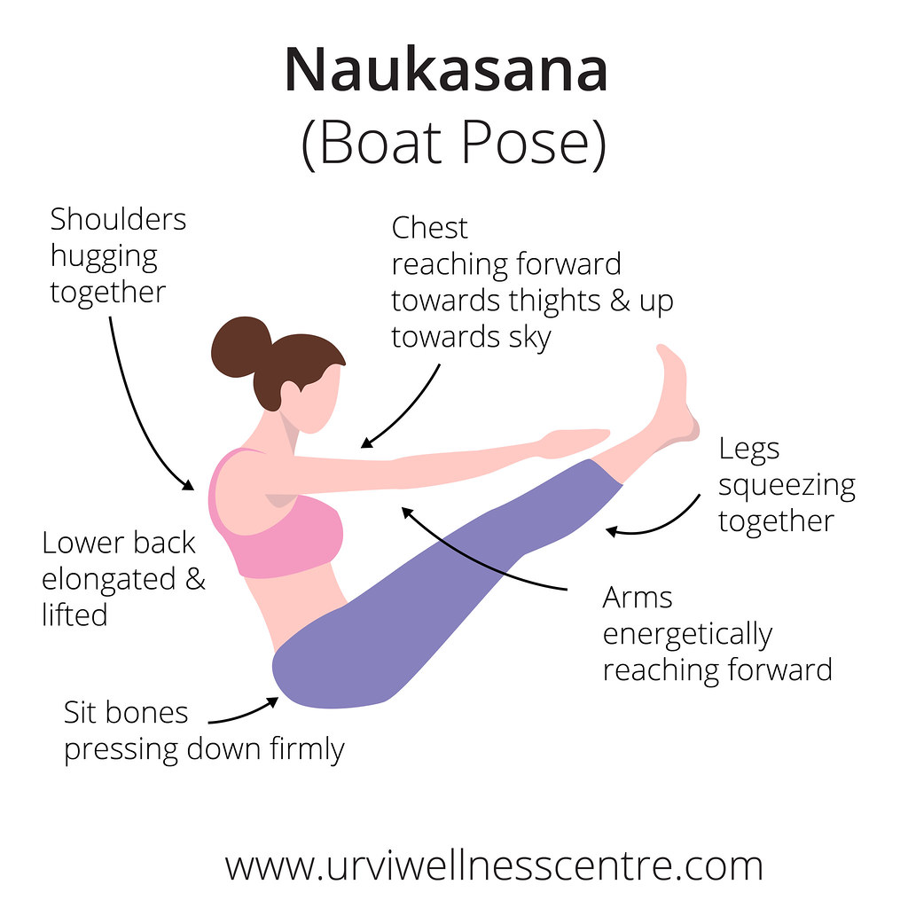

Vakrasana
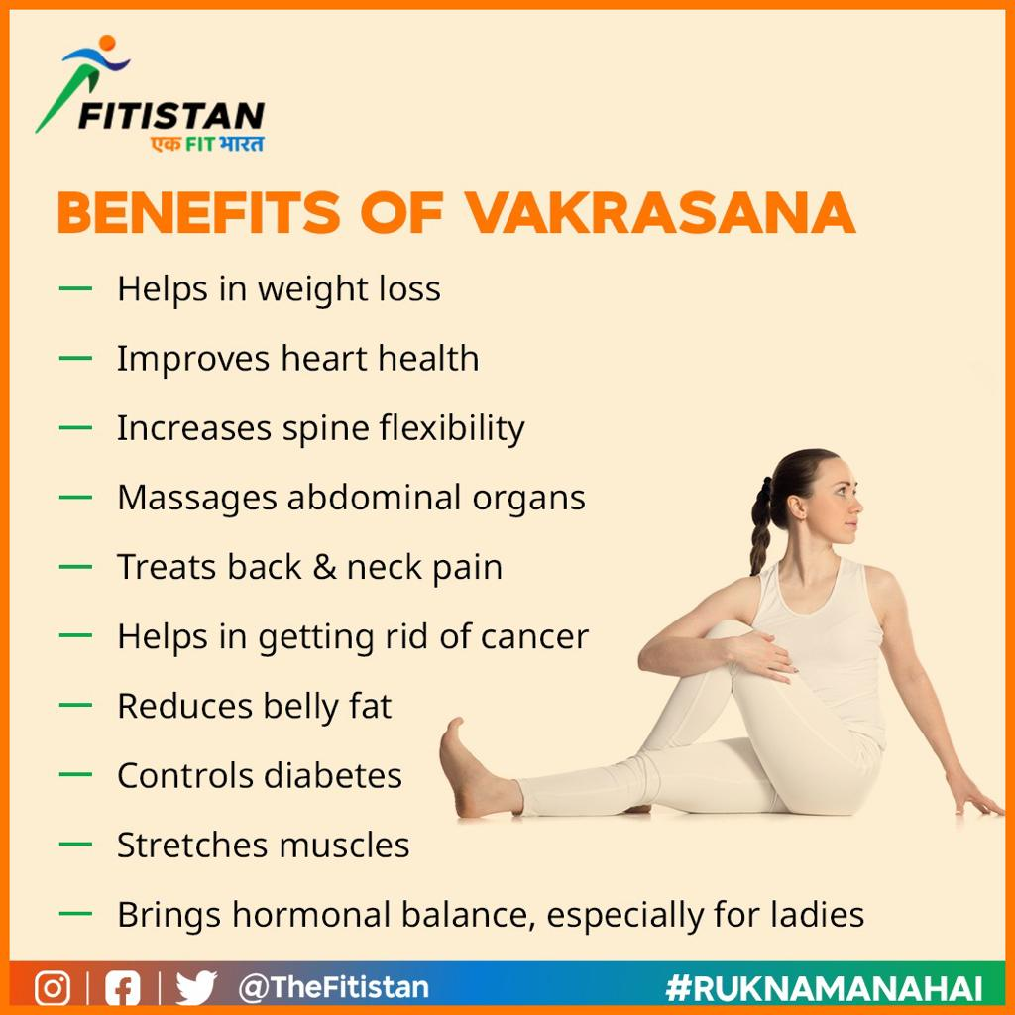
Pawanmuktasana


Sarvangasana
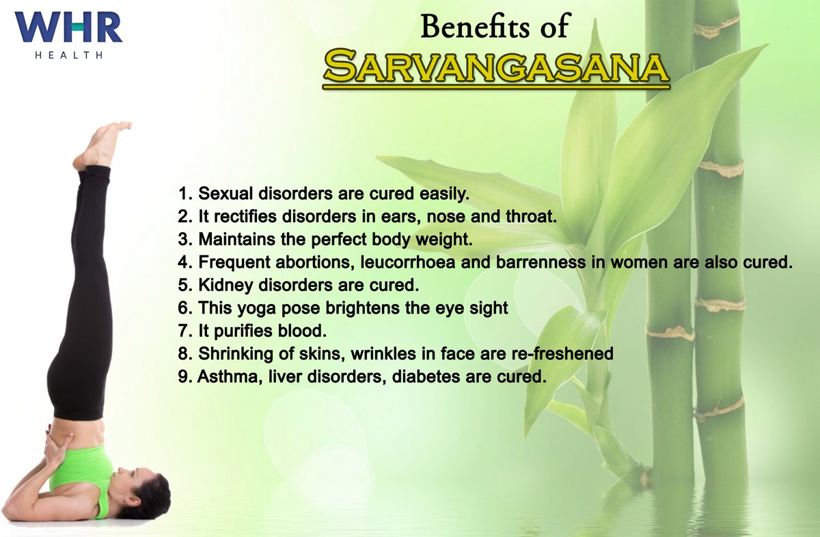

Shavasana
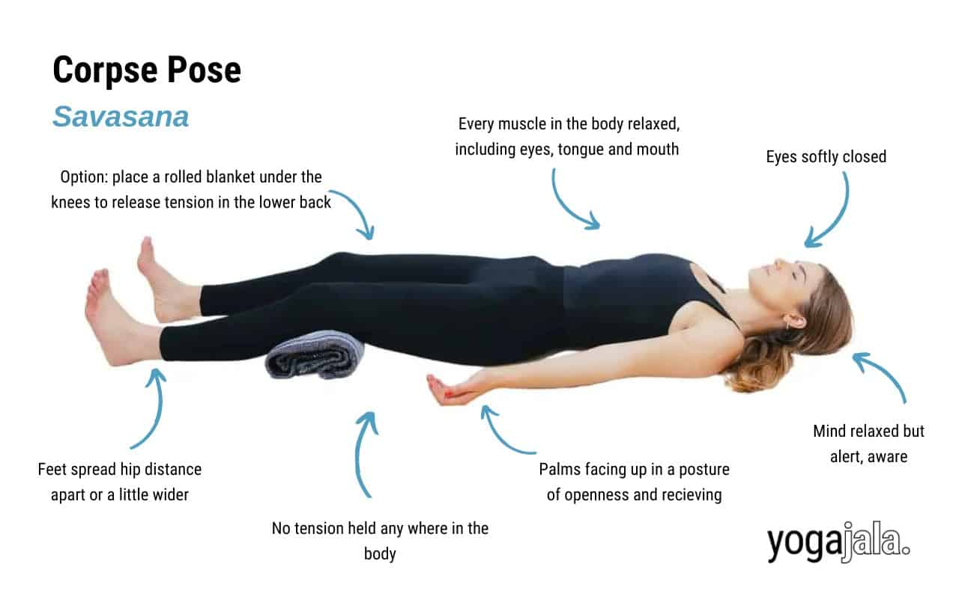

6. Practice following Pranayama for at least one month
-Anuloma- Viloma, Kapalabhati and Bhramari

Anuloma- Viloma
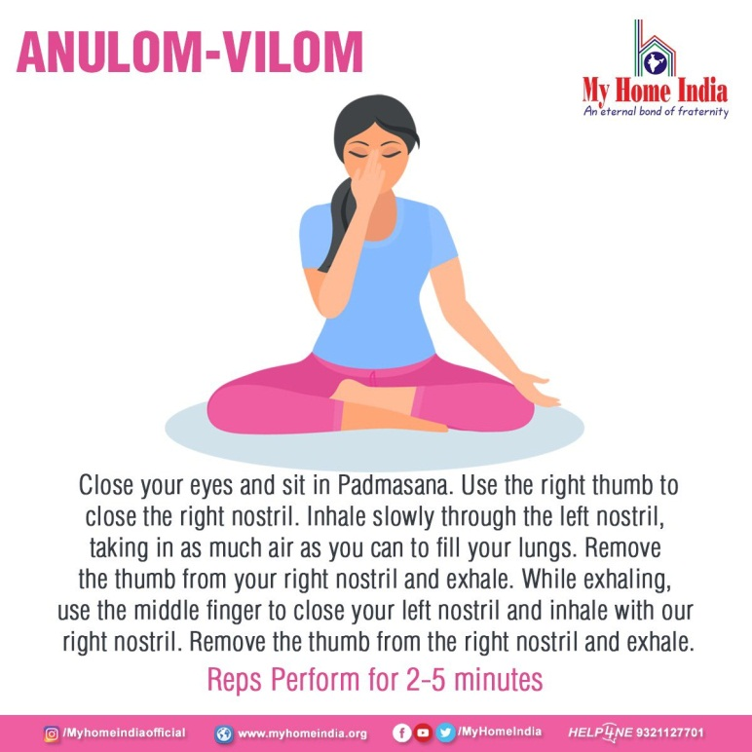
Kapalabhati
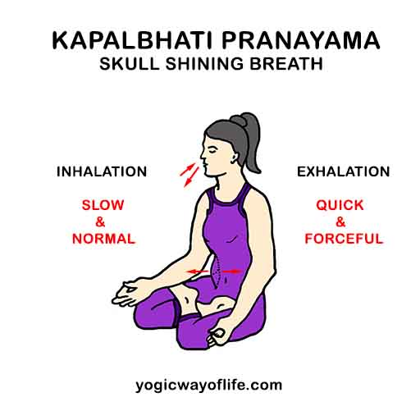

Bhramari
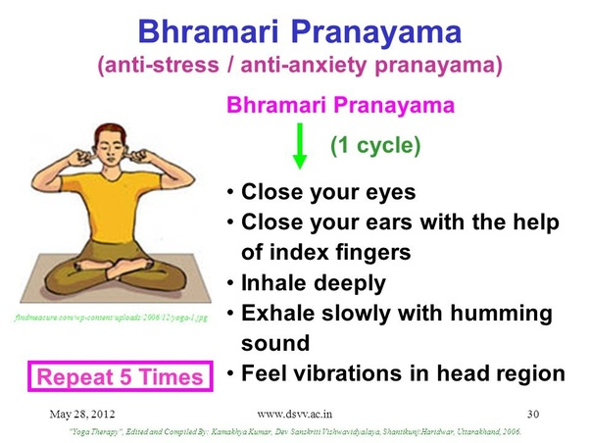

7. Be able to do Tratak for one minute
