
syllabus
- Dig a piece of ground not less than 12 sq. metres. Plant and grow successfully six kinds of vegetables or cities where digging is not possible wooden cases or pots may be used.
- Know names of 12 plants pointed out in an ordinary garden : understand what is meant by pruning, budding, grafting and manuring and demonstrate any one of the following – pruning, budding, grafting.
- Adopt a public park or a neighbour’s courtyard and look after garden/plants for at least two months.

Q1.Dig a piece of ground not less than 12 sq. metres. Plant and grow successfully six kinds of vegetables or cities where digging is not possible wooden cases or pots may be used.

Q 2.Know names of 12 plants pointed out in an ordinary garden : understand what is meant by pruning, budding, grafting and manuring and demonstrate any one of the following – pruning, budding, grafting.

Pruning is the process when individual branches are cut selectively. Shearing is the process when all branches are cut indiscriminately. The latter technique is useful in specialized situations such as maintaining formal hedges or topiaries.
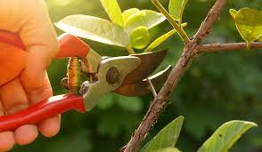
Pruning

Budding is a grafting technique in which a single bud from the desired scion is used rather than an entire scion containing many buds. Most budding is done just before or during the growing season. However some species may be budded during the winter while they are dormant.

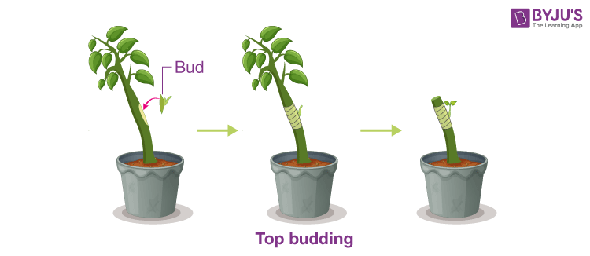
Budding
Manure is the decomposed form of dead plants and animals, which is applied to the soil to increase production. It is a natural form of fertilizer and is cost-effective. The human and animal excreta is also used as manure. The livestock manure is rich in nitrogen, phosphorus, and potassium.
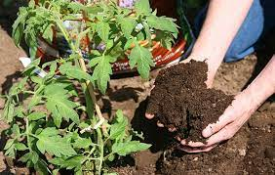
Manuring
3.Adopt a public park or a neighbour’s courtyard and look after garden/plants for at least two months.

