Ecologist syllabus :
(i) Know about the other agencies working for ecological balance.
(ii) Enlist the cooperation of a specialist in the vicinity to educate people about this by way of discussions, audio-visuals, etc.
(iii) Propagate against cutting trees.
(iv) Organise-Van Mahotsavas in monsoons.
(v) Educate people about pollution problems in the area.
(vi) Work for solving any 3 of the following problems :
(a) Air Pollution (b) Killing Animals
(c) Soil Erosion (d) Tree Cutting
(e) Littering (f) Wastage of Water
(g) Water Pollution

(i) Know about the other agencies working for ecological balance.
- Agency for Non-conventional Energy and Rural Technology (ANERT)
- Bombay Natural History Society (BNHS)
- Centre for Science and Environment (CSE)
- Conserve
- Environment Conservation Group
- Environmentalist Foundation of India
- Leaf Bank
- Pasumai Thaayagam TNPT
- Poovulagin Nanbargal
- Pragya India

(Q2) Propagate against cutting trees

1. Trees Turn Carbon Dioxide Into Oxygen
We all know that humans (and almost all living things) need oxygen. Trees use photosynthesis to turn carbon dioxide into oxygen.

2. Trees Clean the Air
Trees can store carbon dioxide in their fibers, which can reduce the negative effects of carbon dioxide on the environment. in just one year a single, mature tree could actually absorb over 48 pounds of carbon dioxide. Since carbon dioxide is the lead contributor to greenhouse gasses, this is a critical role in fighting against global warming. And of course, the trees release oxygen in exchange.

3. Trees Contain Medicine
Trees around the world have been shown to contain vital, active ingredients and healing properties that have long been used in cultures around the world as medicine. Many of these are now also the building blocks of modern medicine.

4.Trees Provide an Energy Break
A mature tree not only provides cool shade to lounge under on a hot day in the summer, but it can also lower your overall energy bill. As long as your tree is close enough to your house to provide a significant amount of shade it can reduce the amount you need to run your air conditioning in the summer by keeping it a little cooler. But trees can also help keep your home a bit warmer in the winter by providing a windbreak, especially if you consider evergreens.
(Q) Educate people about pollution problems in the area
Pollution, also called environmental pollution, the addition of any substance (solid, liquid, or gas) or any form of energy (such as heat, sound, or radioactivity) to the environment at a rate faster than it can be dispersed, diluted, decomposed, recycled, or stored in some harmless form. The major kinds of pollution, usually classified by environment, are air pollution, water pollution, and land pollution. Modern society is also concerned about specific types of pollutants, such as noise pollution, light pollution, and plastic pollution. Pollution of all kinds can have negative effects on the environment and wildlife and often impacts human health and well-being.

Air Pollution
- Air pollution is one of the greatest environmental risk to health. By reducing air pollution levels, countries can reduce the burden of disease from stroke, heart disease, lung cancer, and both chronic and acute respiratory diseases, including asthma.
- In 2019, 99% of the world’s population was living in places where the WHO air quality guidelines levels were not met.
- The combined effects of ambient air pollution and household air pollution are associated with 6.7 million premature deaths annually.
- Ambient (outdoor) air pollution is estimated to have caused 4.2 million premature deaths worldwide in 2019.
- Some 89% of those premature deaths occurred in low- and middle-income countries, and the greatest number in the WHO South-East Asia and Western Pacific Regions.
- Policies and investments supporting cleaner transport, energy efficient homes, power generation, industry and better municipal waste management would reduce key sources of outdoor air pollution. Access to clean household energy would also greatly reduce ambient air pollution in some regions.
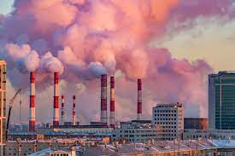

Killing Animals
The killing of animals is animal euthanasia (for pain relief), animal sacrifice (for a deity), animal slaughter (for food), hunting (for food, for sport, for fur and other animal products, etc.), blood sports, roadkill (by accident) or self-defense.
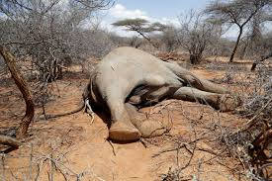
Soil Erosion

What is Soil Erosion?
In this process, the soil particles are loosened or washed away in the valleys, oceans, rivers, streams or far away lands. This has been worsening due to human activities such as agriculture and deforestation.

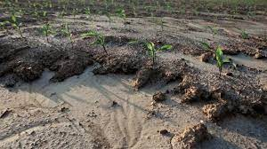

Rainfall and Flooding
Higher intensity of rainstorms is the main cause of soil erosion. Four types of soil erosion are caused by rainfall:
- Rill erosion
- Gully erosion
- Sheet erosion
- Splash erosion
The raindrops disperse the soil, which is then washed away into the nearby streams and rivers. Regions with very heavy and frequent rainfall face a large amount of soil loss. The flowing water during floods also erodes a lot of soil by creating potholes, rock-cut basins, etc.
Soil erosion is a continuous process that occurs either slowly or at an alarming rate. It results in a continuous loss of topsoil, ecological degradation, soil collapse, etc
Tree Cutting
Trees have to breathe to live, same as us and every living thing on the planet. They breathe in carbon dioxide and breathe out oxygen. We breathe out carbon dioxide and breathe in oxygen. We’ve evolved around trees; they are the main things that give off oxygen. Without trees, we’re not here. Cutting down trees takes away that oxygen. If you cut down a tree but plant two new ones that is fine. Trees are living things too.
Littering
Litter consists of waste products that have been discarded incorrectly, without consent, at an unsuitable location. The word litter can also be used as a verb: to litter means to drop and leave objects, often man-made, such as aluminum cans, paper cups, food wrappers, cardboard boxes or plastic bottles on the ground, and leave them there indefinitely or for other people to dispose of as opposed to disposing of them correctly.
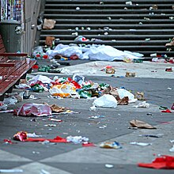
Wastage of Water
The effects of wastage of water are very dire. Many places around the world have no easy access to safe potable water. Furthermore, the cost of desalination and making water potable is constantly increasing.
Wasting of water also have a disastrous effect on the ecosystem. If towns or cities use water from aquatic environments, and if these are not replenished, then the local species which live in these environments may die. In places where water is scarce, any wastage limits the water available for the needs of other people.
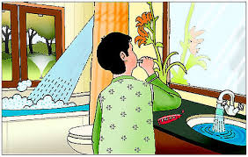
Water Pollution
Water pollution occurs when harmful substances—often chemicals or microorganisms—contaminate a stream, river, lake, ocean, aquifer, or other body of water, degrading water quality and rendering it toxic to humans or the environment.
